Resource Booking System



IT1090 – Information System and Data Modeling

Sri Lanka Institute of Information Technology

**Project ID – MAT_PG.01.01_11**

**Group Details:**

|  |  |  |
| --- | --- | --- |
|  | **Student ID** | **Student Name** |
| **1** | **IT20172350** | **M.P.O.M.Gomes** |
| **2** | **IT20255510** | **Y.N.jayasekara** |
| **3** | **IT20148522** | **Gihan Madhuhara Gamage** |
| **4** | **IT20153618** | **R.Sahan Sandeepa** |
| **5** | **IT20163204** | **N.H.Manimendra** |

**INTRODUCTION**

Under the resources booking system topic we selected hotel resource booking system. In hotel resource booking guest can book room from hotel on internet without wasting time. Also guest can see facilities and book meeting and conference rooms , wedding hall by making simple inquire for hotel. Guest can have special offer and more advantages from this room booking system.

**HYPOTHETICAL SENARIO**

The guest can visit the REDSTONE hotel resource booking system through the internet. There is no need to register in the system to discover hotel facilities and other hotel information for user. To make reservation from system guest must become a registered member. After registering to the system guest can make reservation by entering the payment details to the system. Also , the receptionist can visit the system through the internet and the receptionist must logged into the system for manage payment , check guest details , room availability and respond to the guest inquiries.

Hotel Administer can enter the system by entering admin log in credentials in the log in page. In the backend of the system , admin can see the reports about the gallery and manage the system from full priority.

**REQUIREMENT ANALYSIS**

There are three main users in the system. There are Guest , Receptionist , Admin. Admin and Receptionist has unique admin username and password to log in to the backend of the system. In that most system manage priority have to hotel administer. Guest can log in using their all credentials. Unregistered guest must be registered to the system to log in. In the registering process user must give first name, last name , email , address , phone number , user name and password for the profiles. When guest registered , guest can reserve a room for guest needed. Guest must enter details of check-in date , check-out date , number of adults , number of children for reservation. Then system display the matching room type for guest details and then guest can select room type what they want. Next guest must enter payment details to complete the reservation.

Receptionist is the person who manage the reservations. Receptionist also can make reservation and cancel reservation. Receptionist manage payments and respond to inquires.

Hotel administer is the person who controls the system. Hotel administer can generate reports and monitor processes of the system and update hotel information as add rooms , offers. Also , admin is taking necessary actions by reviewing the feedbacks. Admin has the power to add room , remove room and update hotel information in webpage.

**Entity Relationship (ER) Diagram**

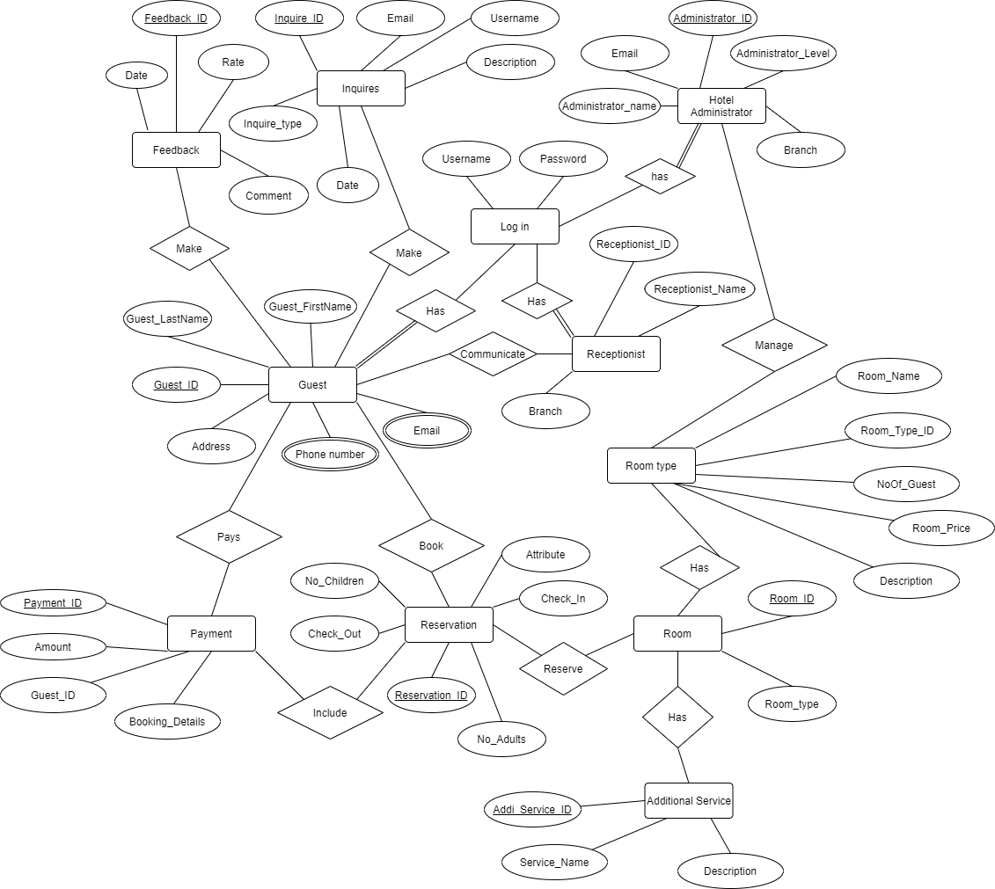

**Relational Model**

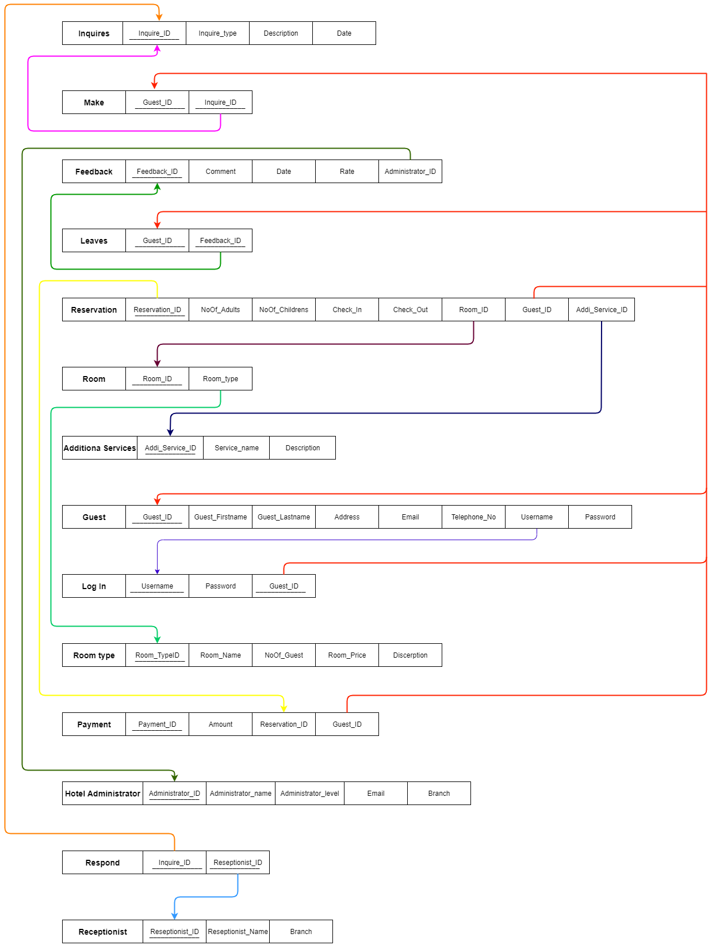

**Special Security Requirements**

The database may be accessed , modified and updated by only the admin and other identified persons where appropriate , to preserve consumers’ security and to retain information without observation or disclosure by other persons. Login is restricted so only the registered user can be logged in.